# Active Directory Domain **E**nvironment

**What is Domain Environment?**

A Windows domain is a form of a computer network in which all user accounts, computers, printers and other security principals, are registered with a central database located on one or more clusters of central computers known as domain controllers.

**What is Active Directory?**

Active Directory is a directory service developed by Microsoft for Windows domain networks. It is included in most Windows Server operating systems as a set of processes and services. Initially, Active Directory was only in charge of centralized domain management.

**What is Kerberos?**

Kerberos is a computer-network authentication protocol that works on the basis of tickets to allow nodes communicating over a non-secure network to prove their identity to one another in a secure manner.

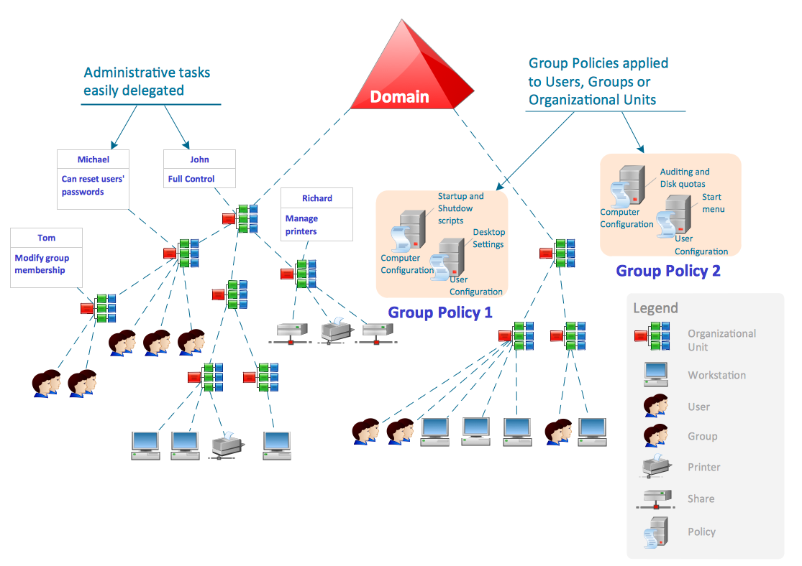

## Software’s in USE:

* **Samba4**
  + Active Directory Environment (Domain & SMB shares)
* **Squid Proxy**
  + Network monitoring & logging
  + Blocking of certain resources
* **DNS Server**
  + maintaining sync for Domains and Addresses
* **VPN server**
  + For accessing SMB Resources Remotely